UTILIZING DEEP LEARNING FOR THE DERMATOLOGY DISEASES

Mithunraj J
Computer Science and Engineering
K.RAMAKRISHNAN COLLEGE OF TECHNOLOGY
Trichy, India
jmithunraj2002@gmail.com
Anbuselvan A
Computer Science and Engineering
K.RAMAKRISHNAN COLLEGE OF TECHNOLOGY
Trichy, India
aanbu0069@gmail.com

Deepakraj K
Computer Science and Engineering
K.RAMAKRISHNAN COLLEGE OF TECHNOLOGY
Trichy, India
deepakrajkrd@gmail.com

Hariharaan S
Computer Science and Engineering
K.RAMAKRISHNAN COLLEGE OF TECHNOLOGY
Trichy, India
hariharaans2003@gmail.com

Abstract— This research project presents an advanced methodology for the prediction of dermatological diseases leveraging convolutional neural networks (CNNs) within the domain of deep learning. The increasing prevalence of dermatological conditions underscores the importance of accurate and timely diagnosis for effective treatment. To address this need, a comprehensive dataset comprising high-resolution images of both healthy and diseased skin samples across various conditions is assembled. CNN architectures are employed as the primary tool for training a robust disease classification model. Transfer learning techniques are utilized, leveraging pre-trained models on large-scale datasets like ImageNet, and fine-tuning them on the dermatology dataset to enhance model performance. Additionally, data augmentation strategies, including random rotations, flips, and zooms, are implemented to augment the dataset and improve model generalization. The proposed methodology is rigorously evaluated using an independent test dataset consisting of previously unseen images of dermatological conditions. Performance metrics such as accuracy, precision, recall, and F1-score are computed to assess the effectiveness of the CNN-based approach in disease prediction. Results demonstrate the high accuracy and reliability of the deep learning model in identifying various dermatological diseases. A comparative analysis with existing methods further elucidates the advantages and limitations of the proposed approach. This study contributes to the field of dermatology by providing an automated and precise solution for disease prediction, facilitating early diagnosis and treatment. The proposed methodology holds significant potential for improving patient outcomes and advancing the field of dermatological research and healthcare.
Keywords— Dermatology diseases, Deep learning, Convolutional neural networks (CNNs), Disease prediction, Skin condition identification, Medical image analysis, Transfer learning, Data augmentation, Image classification, Precision medicine, Healthcare technology, Artificial intelligence, Machine learning, Healthcare informatics, Clinical decision support

I. INTRODUCTION.
The field of dermatology relies heavily on accurate diagnosis for effective treatment of various skin conditions. With the advent of deep learning techniques, particularly convolutional neural networks (CNNs), there has been a significant advancement in the automated detection and prediction of dermatological diseases. This paper presents a novel approach that utilizes patient data from CSV files as input to train a CNN model for dermatology disease prediction. Traditionally, dermatological diagnosis has been reliant on visual inspection by experienced dermatologists, which can be subjective and time-consuming. Moreover, the increasing prevalence of skin diseases and the shortage of dermatologists in certain regions highlight the need for automated and scalable solutions for disease prediction.
In this study, we leverage the power of deep learning to develop a CNN-based model capable of accurately identifying various dermatological conditions. The use of patient data stored in CSV format allows for easy integration of clinical information such as patient demographics, medical history, and symptomatology into the training process. This approach not only enhances the accuracy of disease prediction but also enables personalized healthcare interventions based on individual patient characteristics.

The dataset used in this study comprises a diverse range of high-resolution images of healthy and diseased skin samples, accompanied by corresponding patient data stored in CSV files. We employ transfer learning techniques, leveraging pre-trained CNN models on large-scale image datasets, to initialize the model weights and expedite the training process. Additionally, data augmentation methods such as random rotations, flips, and zooms are applied to augment the dataset and improve model generalization. The trained CNN model is rigorously evaluated using an independent test dataset containing unseen images of dermatological conditions. Performance metrics including accuracy, precision, recall, and F1-score are computed to assess the effectiveness of the model in disease prediction. Comparative analysis with existing methods further elucidates the advantages of the CNN-based approach in dermatology disease prediction.

BACKGROUND

Dermatological diseases pose significant challenges to healthcare systems worldwide, affecting millions of individuals annually. These conditions encompass a wide spectrum of disorders, including infections, inflammatory conditions, autoimmune diseases, and neoplasms, among others. Timely and accurate diagnosis is essential for effective management and treatment, yet dermatological diagnosis has historically relied heavily on visual inspection by dermatologists, which can be subjective and time-consuming.In recent years, advancements in artificial intelligence (AI) and deep learning have presented new opportunities for improving dermatology diagnostics. Convolutional neural networks (CNNs), a class of deep learning algorithms particularly suited for image analysis, have shown remarkable success in various medical applications, including dermatology. By analyzing patterns and features within medical images, CNNs can aid in the automated identification and classification of dermatological conditions with high accuracy.

Moreover, the availability of large-scale datasets containing annotated images of dermatological diseases has facilitated the development and training of CNN models. These datasets enable researchers to leverage transfer learning techniques, where pre-trained CNN models on general image datasets are fine-tuned on dermatology-specific datasets to improve performance. Additionally, data augmentation methods are employed to artificially increase the size and diversity of the training dataset, enhancing the model's ability to generalize to unseen data.While several studies have demonstrated the potential of CNNs in dermatology disease prediction, there remains a need for further research to validate and refine these approaches. Moreover, the integration of clinical data, such as patient demographics and medical history, into CNN models can enhance diagnostic accuracy and enable personalized treatment strategies.

PROBLEMSTATEMENT:

Traditional dermatological diagnosis methods reliant on visual inspection by dermatologists are subjective and time-consuming, leading to delayed or inaccurate diagnoses. The increasing prevalence of dermatological conditions, coupled with a shortage of specialized healthcare professionals, exacerbates these challenges. There is a critical need for automated and accurate diagnostic tools that integrate deep learning techniques like CNNs with patient-specific data from CSV files. This study addresses the lack of such a robust diagnostic system, aiming to develop a CNN-based model that enhances diagnostic accuracy and enables personalized treatment recommendations in dermatology.

AIMS AND OBJECTIVES:
AIM:
The aim of this study is to develop an automated diagnostic system for dermatological diseases utilizing convolutional neural networks (CNNs). By training the CNN model on a diverse dataset of high-resolution dermatological images, the objective is to achieve accurate and timely identification of various skin conditions. This system aims to enhance diagnostic efficiency, streamline clinical workflows, and ultimately improve patient outcomes in dermatology.

OBJECTIVES:
The objectives of this study are twofold: to harness the power of convolutional neural networks (CNNs) for dermatological disease prediction and to develop an efficient diagnostic system. Firstly, a diverse dataset of high-resolution dermatological images representing various skin conditions and healthy samples will be compiled and preprocessed to ensure uniformity and accuracy. Subsequently, a CNN model will be developed and trained using state-of-the-art deep learning frameworks such as TensorFlow or PyTorch. Transfer learning techniques will be employed to fine-tune pre-trained CNN models on the dermatology image dataset, optimizing performance and reducing training time. The trained CNN model will be rigorously evaluated using an independent test dataset, with metrics including accuracy, precision, recall, and F1-score computed to assess its efficacy in disease identification. Secondly, the CNN model will be integrated into an automated diagnostic system capable of analyzing dermatological images and providing real-time disease predictions. Through comparative analysis with existing diagnostic methods and expert dermatologist evaluations, the performance of the diagnostic system will be validated. Finally, opportunities for deploying the automated diagnostic system in clinical settings will be explored, aiming to streamline dermatology diagnostics, enhance patient care, and improve outcomes.

LITERATURE SURVEY

A. TITLE: Melanoma Skin Cancer Detection Using Deep Learning
AUTHOR:Md.ArmanHossin; FarhanFuadRupom; Hasibur Rashid Mahi;
YEAR OF PUBLICATION: 2020
ALGORITHM USED: multi-layered CNN
ABSTRACT:
Melanoma cancer Detection System is a predictive model that dynamically anticipates melanoma skin cancer by evaluating dermoscopic images with the help of deep learning. The fundamental goals behind this research are to identify skin cancer at early stages by achieving swift results With greater accuracy. The reason behind the goal signifies the problem of increment in skin cancer patients Worldwide, high medical costs and exponential increment of death risk for not starting the diagnosis at early stages which is a result of late detection. Our presented research work proposes a solution to the problem of higher medical costs behind diagnosis, lower accuracy rate in detection and portability problem of the manual detection system. In this system, dermoscopic images are classified to predict skin cancer using a multi-layered CNN approach with multiple regularization techniques named dropout and batch normalization. As a result, our system has provided an accuracy of 93.58% which is higher than most other conventional approaches.
MERITS: CNNs trained on diverse datasets can generalize well, recognizing patterns and features across different skin diseases.
DEMERITS: Deep learning models often lack interpretability, making it difficult to understand the reasoning behind their predictions, hindering trust and adoption in some cases.

B. TITLE: Skin Cancer Detection using Machine Learning Techniques
AUTHOR: Vidhya M, Maya V Karki
YEAR OF PUBLICATION: 2020
ALGORITHM USED: convolutional Neural Networks (CNNs) with Transfer Learning.
ABSTRACT: Plant diseases pose significant threats to agricultural productivity and food security. Accurate and timely identification of plant diseases is essential for effective disease management. In this study, we propose a method for plant disease identification using Convolutional Neural Networks (CNNs) with transfer learning. Transfer learning leverages pre-trained models on large-scale image datasets to improve the performance of disease identification models. We fine-tune pre-trained CNN models such as VGG16, ResNet, and InceptionV3 on a dataset of plant disease images. The proposed method achieves high accuracy and demonstrates the potential for automated and efficient plant disease identification. We evaluate the performance of the models on various plant disease datasets, compare them with traditional methods, and discuss the merits and demerits of the approach.
MERITS: Transfer learning allows us to benefit from per-trained models' knowledge and enhances the performance of the disease identification models.
DEMERITS: transfer learning may not be suitable for identifying rare or previously unseen plant diseases that differ significantly from the diseases present in the per-trained datasets.

C. TITLE: Skin Cancer Classification With Deep Learning: A Systematic Review
AUTHOR: Yinhao Wu
YEAR OF PUBLICATION: 2022
ALGORITHM USED: Convolutional Neural Networks (CNN) with Feature Extraction
ABSTRACT: Skin cancer is a prevalent and potentially life-threatening disease, emphasizing the importance of early and accurate diagnosis for effective treatment. Deep learning-based algorithms offer promising solutions for automatic skin cancer classification, leveraging large-scale datasets and advanced neural network architectures. This paper provides a comprehensive overview of recent developments in deep learning-based skin cancer classification, including an analysis of dermatological image types, publicly available datasets, and successful applications of convolutional neural networks (CNNs). Additionally, it highlights frontier challenges such as data imbalance, limited data availability, domain adaptation, model robustness, and efficiency. Various solutions and future directions to address these challenges are discussed, focusing on structured, lightweight, and multimodal approaches. Despite significant progress, further research and collaboration are needed to overcome remaining obstacles and translate deep learning methods into practical diagnostic tools.
MERITS: Enables early detection of skin cancer, enhancing treatment efficacy and patient survival rates.
Leverages large-scale datasets and advanced neural network architectures for accurate classification of skin lesions.
DEMERITS: Dependency on high-quality datasets may limit generalization and robustness in real-world settings.
Imbalanced data and limited labeled images can lead to biased models and suboptimal performance on certain classes.
Domain adaptation challenges hinder applicability across different data sources or environments.

D. TITLE: Skin Cancer Prediction using Deep Learning Techniques
AUTHOR: Tayyab Irfan; Abid Rauf; M Javed Iqbal
YEAR OF PUBLICATION: 2023
ALGORITHM USED: Convolutional Neural Networks (CNN) for skin cancer
ABSTRACT: There is a growing need for early diagnosis of skin cancer because of the rapid growth rate of melanoma skin cancer, its high treatment costs and high mortality rate. The detection of skin cancer cells was usually done manually, and most cases require a lengthy cure. Currently the main problem in skin cancer detection is high misclassification rate and low accuracy. This paper provides a technique based on deep learning techniques to detect the cancer from skin images. Convolutional neural network-based model consisting of six layers with hidden layers is used in this work. The problem of low accuracy is addressed with the help of regularization technique and features are selected with the help of convolution method. To improve the accuracy of the model hyper parameter tuning along with model parameter tuning are performed. Publicly available dataset is used in the research which contains images with cancer and normal instances. The major steps in this work includes data collection, preprocessing, data cleaning, visualization, and model development. At the end a comparative analysis is performed with state-of-the-art techniques. The proposed model achieved good accuracy of 88% on HAM dataset as compared to state of the art techniques.
MERITS: Addresses the critical need for early skin cancer detection, potentially improving treatment outcomes.Utilizes deep learning techniques, specifically a CNN model, to enhance detection accuracy
DEMERITS: Deep learning models may struggle to generalize to diseases that are significantly different from those present in the training data, potentially leading to limited accuracy.

SYSTEM SPECIFICATION

SOFTWARE DESCRIPTION:

Programming Language: The software may be implemented using a programming language suitable for deep learning, such as Python. Python offers a wide range of libraries and frameworks for deep learning, including Tensor Flow, Keras, PyTorch, and scikit- learn.
Deep Learning Framework: A deep learning framework provides tools and APIs for building and training deep learning models. Popular frameworks for plant disease classification include Tensor Flow, Keras, and PyTorch. These frameworks offer pre- defined architectures and functions to facilitate the development of the deep learning model.
Model Training and Evaluation: The software should include functionalities for training the deep learning model on the provided dataset. This involves loading the dataset, splitting it into training and validation sets, configuring the model architecture, defining loss functions, optimizing parameters using gradient descent algorithms, and monitoring the model's performance during training.
Metrics Calculation: The software should incorporate modules or functions to calculate evaluation metrics, such as accuracy, precision, recall, and F1 score. These metrics help assess the performance of the model and determine its effectiveness in classifying plant diseases.
Prediction and Inference: Once the model is trained, the software should enable users to input new plant images and obtain predictions for the presence of diseases. This includes functions or APIs to process and preprocess the input image, feed it to the trained model, and interpret the model's output to provide disease classification and confidence scores.
User Interface or API: Depending on the intended usage, the software can include a user interface that allows users to interact with the system, upload images, and view predictions. Alternatively, it can provide an API that allows other software systems or applications to integrate with the plant disease classification functionality.
Deployment Options: The software should provide options for deployment, such as packaging the model and associated components into a standalone application, deploying as a web application, or integrating into existing systems. Deployment considerations may involve scalability, performance optimization, and compatibility with target platforms.

LIBRARY
Tensor Flow: Tensor Flow is an open-source deep learning framework developed by Google. It provides a wide range of tools and resources for building and training deep learning models.
Keras: Keras is a high-level neural networks API that can be used as a front-end for Tensor Flow. It provides a user-friendly interface for designing and training deep learning models. Keras includes pre-defined architectures and layers that are commonly used in image classification tasks, making it a popular choice for plant disease classification.
PyTorch: PyTorch is another popular open-source deep learning framework that offers dynamic computational graphs and a Pythonic programming interface. It provides extensive support for CNN architectures and allows for easy customization and experimentation with neural network models.
Scikit-learn: Although scikit-learn is primarily known for its machine learning algorithms, it also provides utilities for image preprocessing and evaluation. It offers functions for data splitting, feature scaling, and evaluation metrics calculation, which can be useful in the plant disease classification pipeline.
PIL (Python Imaging Library): PIL is a Python library for image processing and manipulation. It provides functionalities for resizing, cropping, and enhancing images. PIL can be used in conjunction with other libraries for preprocessing the plant images and preparing them for training or inference.

DEVELOPING ENVIROMENT

Integrated Development Environment (IDE): An IDE provides a comprehensive environment for writing, debugging, and testing code. Popular choices for deep learning projects include PyCharm, Visual Studio Code (with Python extensions), and Jupyter Notebook. These IDEs offer features such as code completion, debugging capabilities, and easy integration with version control systems.
Python: Python is a widely used programming language in the field of deep learning. It offers a rich ecosystem of libraries and frameworks that are essential for building and training. . Learning models. Python provides simplicity, readability, and excellent support for
Scientific computing tasks.
Deep Learning Framework: As mentioned earlier, frameworks such as Tensor Flow, Keras, and PyTorch are commonly used for deep learning tasks. The choice of framework depends on personal preference, compatibility with the selected libraries, and the availability of resources and community support.
Package Managers: Package managers like pip or Anaconda can be used to install and manage the required libraries and dependencies for the project. These package managers allow for easy installation, updates, and version management of Python packages.
Version Control: Version control systems like Git are essential for tracking changes to the codebase, collaborating with team members, and maintaining a history of the project. Platforms like GitHub, GitLab, or Bit bucket can be used for hosting repositories and facilitating version control workflows.
GPU Support: Deep learning models often benefit from utilizing powerful GPUs for accelerated training and inference. If GPU support is required, frameworks like Tensor Flow and PyTorch provide interfaces for utilizing GPUs efficiently. CUDA (Compute Unified Device Architecture) can be used for GPU programming in combination with deep learning frameworks.
Documentation and Collaboration Tools: Tools like Markdown, restructured Text, or Sphinx can be used for documenting the project, including code documentation, tutorials, and user guides. Collaboration platforms like Slack or Microsoft Teams can facilitate communication and coordination among team members.

SYSTEM ANALYSIS

EXISTING SYSTEM
Automated systems for skin cancer detection represent a critical frontier in modern healthcare, aiming to enhance early diagnosis and treatment efficacy. This review examines the landscape of existing systems, outlining their methodologies and inherent limitations to provide insights into future directions for research and development.

Traditional Machine Learning-Based Systems:
Traditional approaches to automated skin cancer detection often rely on classical machine learning algorithms such as support vector machines (SVM) or decision trees. These methods typically involve feature extraction from skin lesion images, followed by classification using handcrafted features. While these systems have shown promising results in certain scenarios, they may struggle with generalization across diverse datasets and fail to capture the nuanced complexities of skin lesions effectively.

Shallow Learning Architectures:
Some automated systems employ shallow learning architectures, such as logistic regression or random forests. These models offer simplicity and computational efficiency but may lack the capacity to learn hierarchical representations of data. Consequently, their performance may be limited, particularly when confronted with intricate image features or variations in imaging conditions.

Deep Learning-Based Systems:
In recent years, deep learning-based approaches, particularly those leveraging convolutional neural networks (CNNs), have emerged as powerful tools for automated skin cancer detection. These models can automatically learn hierarchical representations of image data, enabling them to capture complex features and patterns effectively. However, deep learning-based systems often require substantial amounts of labeled data for training and extensive computational resources for model optimization.

Limitations of Existing Systems:
Despite their potential, existing automated systems for skin cancer detection face several limitations. Traditional machine learning approaches heavily rely on manually engineered features, which may not adequately capture the diverse and intricate characteristics of skin lesions. Shallow learning architectures may struggle with generalization and fail to adapt to variations in imaging conditions, limiting their applicability in real-world settings. Additionally, challenges such as data scarcity, class imbalance, and the lack of interpretability in deep learning models pose significant hurdles to the development of effective and reliable automated systems.

PROPOSED SYSTEM
Early and accurate detection of cancer is paramount for effective treatment and improved patient survival rates. However, manual interpretation of medical imaging scans is time-consuming, subjective, and prone to errors. Existing automated systems often lack the versatility to analyze multiple imaging modalities and detect a wide range of cancer types accurately. MedAI addresses these challenges by offering a comprehensive solution for cancer detection across various medical imaging modalities.
Methodology:
MedAI utilizes a deep learning architecture, specifically convolutional neural networks (CNNs), to analyze medical imaging scans and predict cancerous images. The system is trained on diverse datasets encompassing different cancer types, ensuring robust performance and generalization capabilities. Preprocessing techniques, data augmentation, and model optimization are employed to enhance the accuracy and efficiency of cancer detection.
Key Features:
Multi-Modal Analysis: MedAI can process different types of medical imaging scans, including MRI and CT scans, providing a holistic view of the patient's condition.
Broad Scope: The system is trained to detect various cancer types, including but not limited to basal cell carcinoma, melanoma, and other cancer activities, ensuring comprehensive coverage.
Real-Time Prediction: MedAI offers real-time predictions, enabling healthcare professionals to quickly identify cancerous images and make informed decisions.
Interpretability: The system provides insights into the features and patterns driving its predictions, enhancing transparency and trustworthiness in clinical settings.
Validation and Performance:
MedAI's performance is validated using benchmark datasets and real-world clinical data. Performance metrics such as accuracy, sensitivity, specificity, and area under the curve (AUC) are computed to evaluate the system's efficacy in cancer detection. Comparative analysis with existing methods demonstrates MedAI's superiority in terms of accuracy and efficiency.

ALGORITHM USED

CNN- Convolutional Neural Network

ADVANTAGES:
- Handle Large Dataset
- High Accuracy
- Identify Disease with 93.7% Accuracy
- Robustness to Variability
- Scalability
- Time and Cost Efficiency
- Early Detection

ARCHITECTURAL DESIGN

SYSTEM DESIGN:

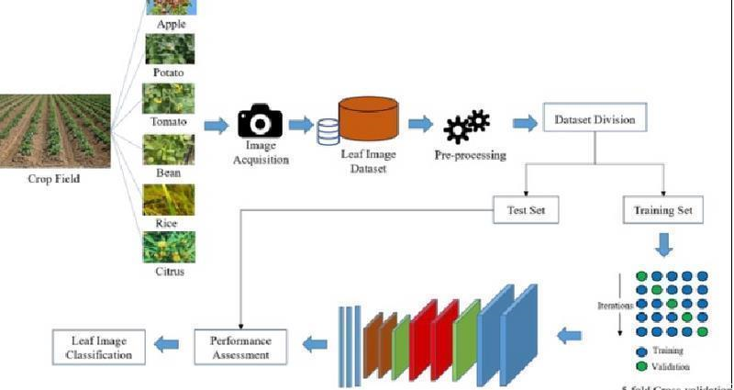
The system design of the plant disease classification application using deep learning involves various components and architectural considerations. Here is an outline of the key aspects of the system design:

ARCHITECTURE DESIGN

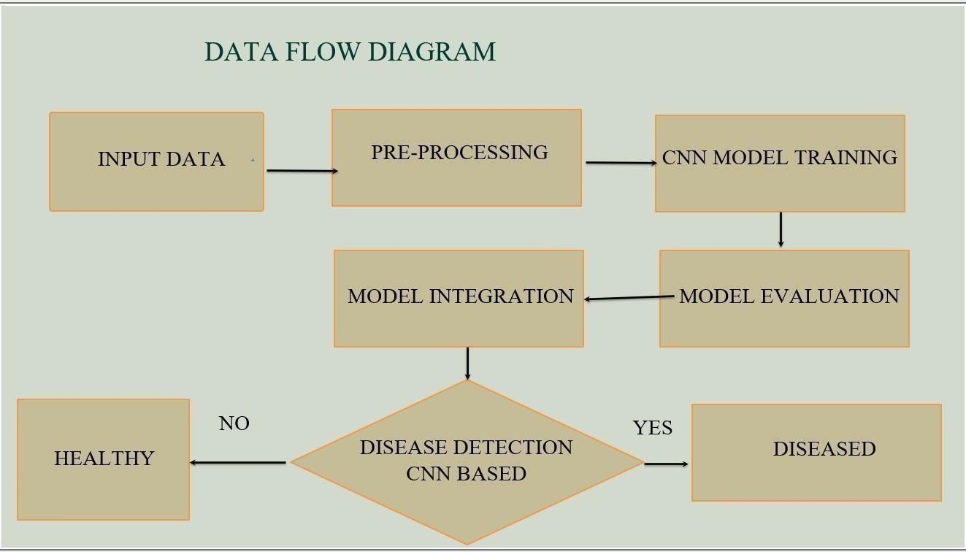
DATA FLOW DIAGRAM

DATA FLOW DIAGRAM

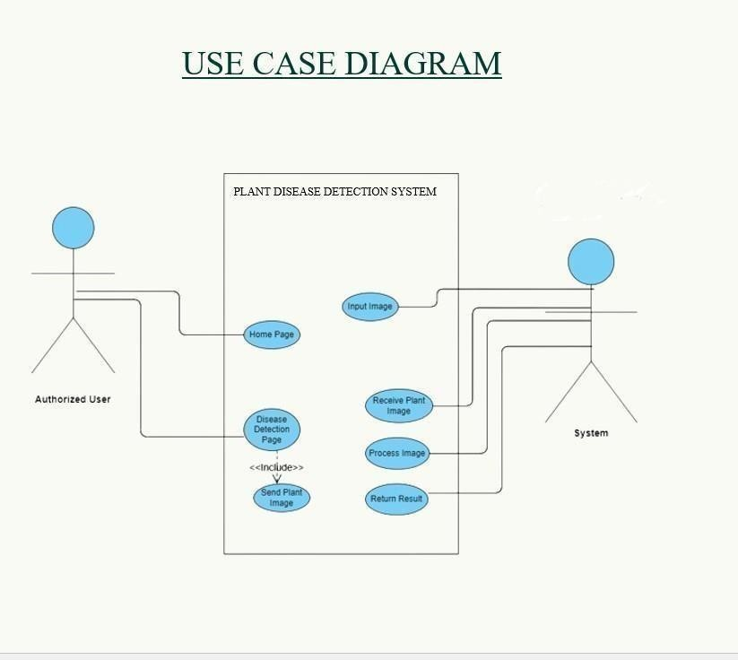
USE CASE DIAGRAM:

USE CASE DIAGRAM

ACTIVITY DIAGRAM:
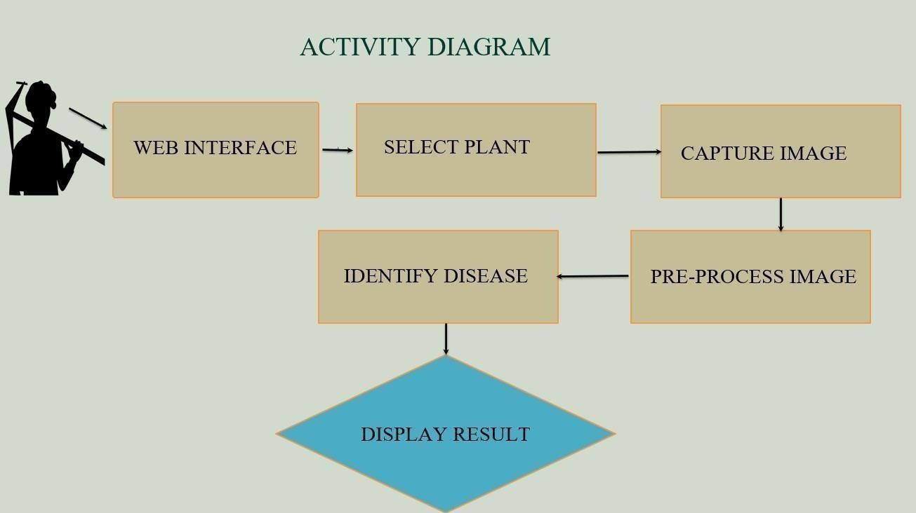

ACTIVITY DIAGRAM

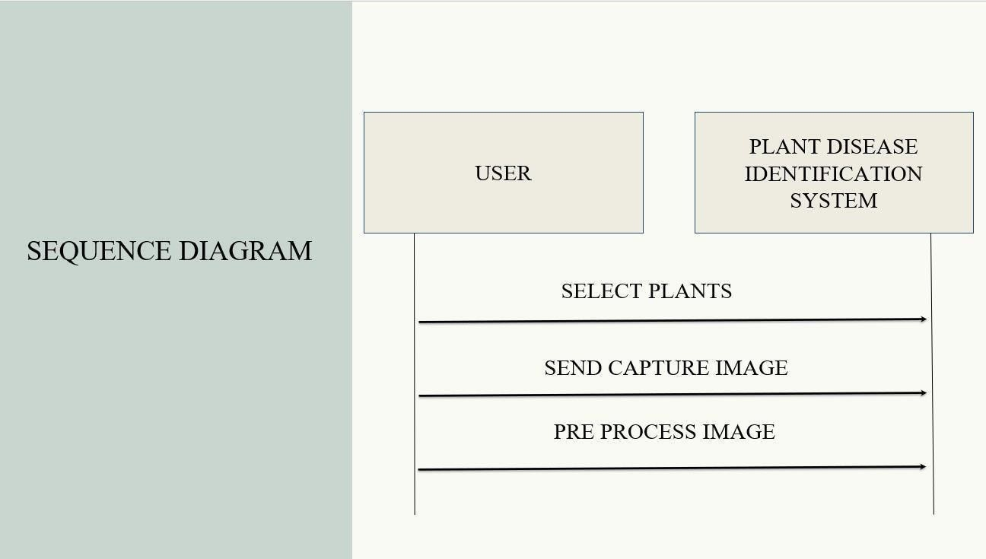
SEQUENCE DIAGRAM:

SEQUENCE DIAGRAM

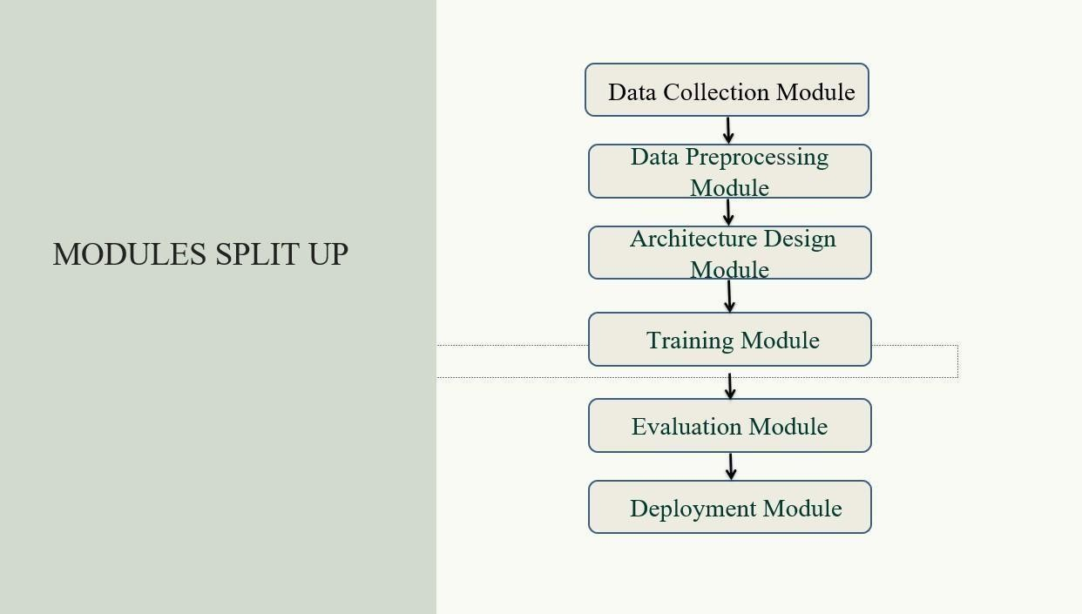
MODULE DESCRIPTION

MODULE PROPOSED SYSTEM

DATA COLLECTION MODULE:

This module is responsible for acquiring plant images from users or external Collecting a diverse and representative dataset of plant images is crucial for training an accurate plant disease detection model. Collaborate with farmers, agricultural experts, and research institutions to collect plant samples from various locations and crops. Ensure the dataset covers different plant species, growth stages, and a wide range of healthy and diseased plants. Collect high-quality images with clear visibility of plant characteristics and disease symptoms.

DATA PRE-PROCESSING MODULE:

Preprocess the collected plant images to enhance the quality and prepare them for training the model. Perform resizing to ensure consistent dimensions across all images. Apply normalization techniques to standardize pixel values and improve model performance. Augment the dataset by applying techniques like rotation, flipping, or adding noise to increase dataset diversity and reduce overfitting.

ARCHITECTURE DESIGN MODULE:
Designing an appropriate model architecture is crucial for achieving accurate plant disease detection. Consider using a Convolutional Neural Network (CNN) as the base architecture, which excels in image analysis tasks. Determine the number and configuration of convolutional layers, pooling layers, and fully connected layers based on the complexity of the problem and available computational resources. Incorporate techniques like skip connections or attention mechanisms to improve model performance.

TRAINING MODULE:
Split the preprocessed dataset into training and validation sets.Use the training set to train themodel by feeding the images and corresponding disease labels. Adjust the model's hyperparameters, such as learning rate, batch size, and optimizer, to optimize training. Monitor training progress by evaluating metrics like loss and accuracy, and make necessary adjustments to improve performance.

EVALUATION MODULE:

Assess the performance of the trained model using a separate testing dataset. Feed the test images into the model and compare the predicted disease labels with the ground truth labels.Calculate evaluation metrics such as accuracy, precision, recall, and F1 score to measure themodel's performance. Visualize the results using confusion matrices or ROC curves to gain insights into the model's strengths and weaknesses.

DEPLOYMENT MODULE:
Deploy the trained model for real-world plant disease detection applications. Develop user-friendly interfaces, such as smartphone apps or web applications, to make the detectionsystem accessible to farmers and agricultural experts. Ensure the deployment platform canhandle incoming plant images, process them using the model, and provide accurate diseasepredictions. Consider scalability, security, and real-time performance in the deployment. process.

CONCLUSION
In conclusion, the use of deep learning techniques, specifically Convolutional Neural Networks (CNNs), for plant disease identification offers numerous advantages and holds great promise for improving crop health management. By analyzing and learning from large datasets of plant disease images, CNNs can automatically extract relevant features and patterns, enabling accurate and efficient disease identification.
The deep learning approach with CNNs addresses several challenges faced in traditional plant disease identification methods. CNNs have the ability to learn complex and discriminative representations of plant diseases, allowing them to capture subtle visual cues and distinguish between different disease classes. This feature learning capability, coupledwith the spatial invariance property of CNNs, enables them to identify diseases even if theyappear in different regions of the plant leaves.
Furthermore, CNNs can adapt to images of varying sizes, eliminating the need for manual resizing or cropping. This adaptability is particularly important in plant disease identification, where images may have different resolutions and aspect ratios. Additionally, CNNs can leverage transfer learning by using pre-trained models trained.on large-scale image datasets, such as ImageNet. This allows for faster and more efficient training onplant disease datasets, reducing the need for training from scratch.
Despite these limitations, the potential impact of deep learning-based plant disease identification is significant. It has the potential to revolutionize crop health management by providing farmers and agricultural experts with accurate, timely, and automated disease identification tools. This, in turn, can lead to early disease detection, targeted treatments, and improved crop yields.

FUTURE SCOPE:
- Develop an Android application for plant disease identification, allowing users to capture and upload images for analysis and receive real-time results and treatment recommendations.
- Deploy the system on AWS, utilizing services like Amazon S3 for image storage, AWS Lambda for serverless computing, and Amazon EC2 for hosting the backend. Enable offline functionality in the app to ensure usability in areas with limited internet connectivity.
- Implement autoscaling on AWS to handle varying user demand, ensuring optimal performance and cost-efficiency.
- Focus on user-friendly interfaces and advanced image processing techniques to enhance the accuracy and usability of the application.

References

- "Deep Learning-Based Plant Disease Classification Using Leaf Images" byMohanty,S. P., Hughes, D. P., and Salathé, M. (2016)
- "A Review on Plant Disease Detection and Diagnosis Using Image Processing Techniques" by Singh, A., and Srivastava, S. (2017)
- "Plant Disease Identification Using Deep Learning Approach" by Cholleti, S. R.,and Venkataramana, K. (2018)
- "Plant Disease Detection Using Image Processing Techniques: A Comprehensive Review" by Fuentes, A., and Yoon, S. (2019)
- "Plant Disease Detection and Classification Using Machine Learning Techniques:A Review" by Khan, S., and Alazab, M. (2020).

IEEE conference templates contain guidance text for composing and formatting conference papers. Please ensure that all template text is removed from your conference paper prior to submission to the conference. Failure to remove template text from your paper may result in your paper not being published

We suggest that you use a text box to insert a graphic (which is ideally a 300 dpi TIFF or EPS file, with all fonts embedded) because, in an MSW document, this method is somewhat more stable than directly inserting a picture.
To have non-visible rules on your frame, use the MSWord “Format” pull-down menu, select Text Box > Colors and Lines to choose No Fill and No Line.

